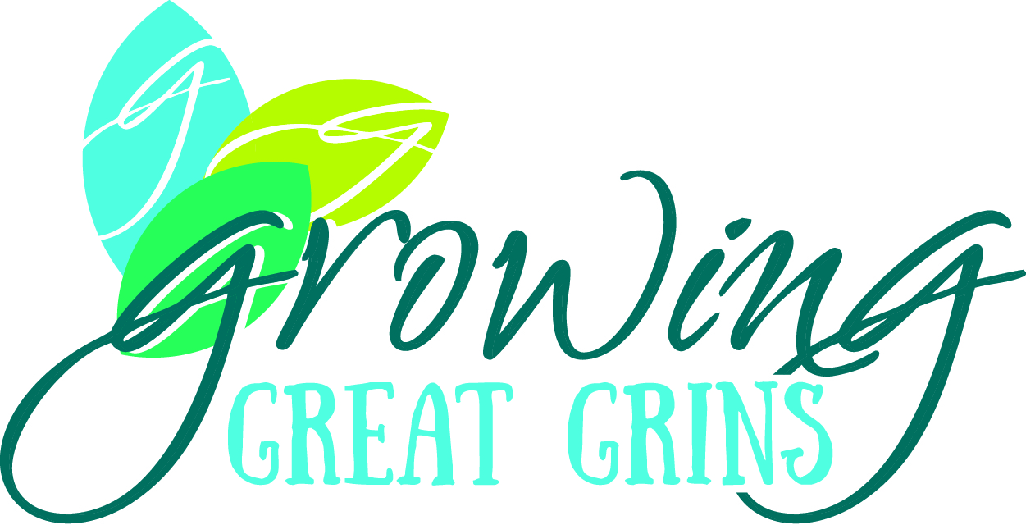
Leslie Blackburn, DDS, MA
4119 Calvert Cove Court, Spring, TX 77386
leslieblackburn0204@gmail.com
484-682-7912
www.growinggreatgrins.com

Rogue pediatric dentist with dangerously high levels of self-efficacy and her own kingdom to guide and shape. Committed to honoring the trust given her by the families she is privileged to assist by helping children develop the skills necessary to succeed in the dental chair and in life.

Employment History (with descriptions listing experience with perceived importance for this project):
- Owner / Pediatric Dentist, Growing Great Grins: November 2017 – Present
    - 1001 Medical Plaza Dr, Ste 350, The Woodlands, TX 77380
  - Run successful small business.
  - Practice pediatric dentistry, applying behavior management skills (jargon used to refer to skills for helping to help children tolerate dentistry) in various dental contexts with children and youth.
  - Develop a program for trying to cultivate dental coping skills over a longer period of time than is traditional in dentistry.
  - Lead, motivate, and guide a team of 9-11 people (currently 10).
  - Grow the leaders in a leadership team of 3.
- Managing Partner, The Woodlands Dental Group: January 2019 – Jan 2024 (hopefully)
    - 1001 Medical Plaza Dr, Ste 300, The Woodlands, TX 77380
  - Coordinated the running of a collaboration of 7 dental practices.
  - Brought together 7 owners whose full-time jobs do not involve running their businesses and guided them towards making decisions for the larger business.
  - Helped approximately 50 employees navigate cordial interpersonal relationships at work.
  - Restructured business operations in a business grown organically over 30 years.
- Pediatric Dental Associate, Judith Ragsdale Pediatric Dentistry: September 2014 – November 2017
    - 1001 Medical Plaza Dr, Ste 350, The Woodlands, TX 77380
  - Practiced pediatric dentistry (see previous notation).
  - Developed marketing strategies to capture the vision of the owner on the budget assigned.
  - Hired employees who match the vision of the owner.
- Laboratory Technician, University of Pennsylvania, Robert Doms lab: August 2004 – July 2008
    - 319 Johnson Pavilion, Philadelphia, PA, 19104
  - Carried out assays and experiments according to the plan developed by the post-doctoral student assigned, investigating the reason for failure of T-20 (or enfuvirtide) in HIV patients.
  - Made sure stock of lab materials like bacterial cultures and plates remain full.
- Director of Children’s Program, House of Hope: July 2003 – August 2004
    - 1726 Buckley Ln, Provo, 84606
  - Developed a program of emotional development for children of mothers with addiction in a residential drug rehabilitation program, program lasting about 3 months for 3 different age groups.
  - Hired staff to run the program and led said team.
  - Logged daily challenges or improvements for each child in the program.
  - Administered all disciplinary care needed for all children in the program to avoid disruption for the teachers hired for all age groups.
  - Taught occasional classes to mothers with addictions on child emotional development.

Pertinent Volunteering History:
- 7 and 8th Grade Science Teacher, Columbia University College of Dental Medicine educational enrichment program: August 2008 – May 2012:
  - Taught science-enrichment program on Saturday mornings, 1 hour per class, 2 classes.
  - Developed and administered quizzes and tests for the students.
  - Graded and reported progress for students.
- Intake Psychological Testing Administrator, Utah State Prison: 2002 (I no longer remember the exact months, but about 6 months):
  - Administered intake psychological tests as dictated by the prison psychologists.
  - Assisted prison psychologists in grading and interpreting the intake exams.
  - Accompanied prison psychologists on rounds, and discussed cases with them.

Education:
- Masters of Applied Positive Psychology, University of Pennsylvania, Philadelphia, PA
  - August 2024 – August 2025 (if I can get this project done!!)
- Pediatric Dental Residency, Yale-New Haven Hospital, New Haven, CT
  - June 2012 – August 2014
- Masters of Science and Dental Education, Teachers College, New York, NY
  - August 2010 – May 2012
- Doctor of Dental Surgery, Columbia College of Dental Medicine, New York, NY
  - August 2008 – May 2012
- Post-Baccalaureate Coursework, University of Pennsylvania, Philadelphia, PA
  - January 2005 – December 2007
- Bachelors of Arts in Psychology, Brigham Young University, Provo, UT
  - August 2000 – August 2003

